**Recent credit and monetary policies of Indian banking system**

**[Definition]** Monetary Policy is a macroeconomic policy (सम_È आÉथक नी_त), designed by the central bank of

a country, to manage money supply & interest rates. It helps shaping variables such as inflation,

consumption, savings, investment, and capital formation

- **[Significance]** Monetary policy plays an important role in price stability [inflation control], economic

growth, job creation and social justice in any economy.

- **Milton Friedman**: American economist whose research on monetary policy made this subject more

popular, he also won a Nobel in Economics in this regard (1976).

- **Philip Curve**: Inflation ↑ = unemployment ↓ (and vice versa).

- Therefore, stable & moderate inflation is good for the economy.

So, RBI tries to keep inflation with 2-6% Consumer Price Index (CPI: All India) using its bi-monthly

monetary policy made by its 6- member statutory Monetary Policy Committee.

**MONPOLICY: QUANTITATIVE TOOLS** Also known as (aka) **General or Indirect Tools** as they affect the entire economy, and not just a particular sector.

CRR and SLR are collectively known as “**Variable Reserve Ratios**” or “**Statutory Reserve Ratios**”

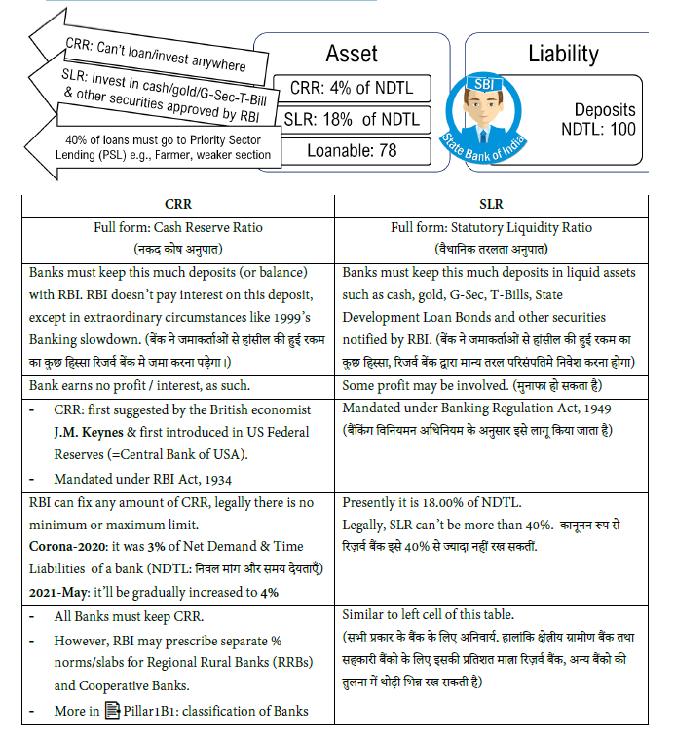

CRR-SLR are counted on fortnightly basis. If not maintained, bank will have to pay penalty interest rate

to RBI. This Penalty rate is linked with **Bank Rate**. (हर 15 िदनो ं के .लए .गना जाता है. नही ं माना तो जमु ार्ना लगेगा.)

- CRR-SLR ensure monetary stability of India through **two primary functions:**

1) CRR assists in money multiplier effect,

2) CRR-SLR provide buffer/protection during a **Bank Run (बक. ो ं म. से जमारा.श वापस लने े क_ दौड़)** i.e. an

emergency when every depositor wants to pull out money from his bank account at once, mainly

due to fake news / rumors.

- While in theory CRR/SLR can be used for inflation control but RBI primarily relies on REPO Rate (=its

Policy Rate) to combat inflation, and not CRR/SLR. (हालांिक, महंगाई _नयंत्रण के यह मुÙ साधन नही ं है)

**12.12** 🐯🐯🐯🐯✂🗓🗓 **CRR, SLR: DEVELOPMENT IN RECENT YEARS**

**12.12.1** 🐯🐯🐯🐯✂🗓🗓 **(2016): Incremental CRR during Demonetization (नोटबंदीमे वृ.द्धशील सीआरआर)**

- During demonetization (2016-17): public required to deposit the banned ₹500-1000 ke notes in banks.

So, banks’ deposits increased drastically.

- During that time, RBI temporarily prescribed **Incremental CRR**.

✋What was it? how did it work? **Ans**. 6 years old technical topic for Prelims-2022. Very poor

cost benefit in preparing #🕰🕰थोड़ा-पढ़ो-आगे-बढ़ो. उस 6 साल पुराने मुददे क_ अब पंचात करने नहीं बैठ.गे

**12.12.2** 🐯🐯🐯🐯✂🗓🗓 **(2020-Feb) CRR Exemption for 5 yrs, depending on loans (सीआरआर म . छू ट)**

**2020-Feb:** RBI instructed the banks:

⇒ Whatever new (retail) loans you give for (1) automobiles (2) residential housing / home mortgages. (3)

MSMEs [After 31/Jan/2020 upto 31/Jul/2020]. Some of these deadlines later extended but PHDNOTIMP

⇒ You can subtract that much loaned ₹₹ amount from deposits while computing cash reserve ratio (CRR)

for the next five years (from the date when the loan was given or other technical norms, which are not

important). (यिद ब§कर ने वाहन, मकान और छोटे उद्योगो ं को कजर् िदया, तो सीआरआर म. उस ब§क को छू ट .मलेगी)

⇒ In other words, if a bank gives more loans to the above 3 sectors, it’ll have to keep ⏬ CRR → ⏫

loanable funds → profit to the bank. And more loans → more business activity → economic growth for

the country. (देश क_ आÉथक वृ.द्ध म. मदद होगी)

**12.12.3** 🐯🐯🐯🐯✂🗓🗓 **(2020-Mar) CRR** ⏬ **from 4% to 3% in** 👻👻**Atmanirbhar Bharat**

To revive Indian economy after Corona, RBI made certain changes in its monetary policy during March-

April-2020 period.

- Parallelly, Govt also took announced relief in tax-filling, free-food to poor etc.

Collectively, Modi labelled these actions of [RBI + Government] = “**Atmanirbhar Bharat Economic**

revival package”. 📑📑More in Pillar#4C.

⇒ **2020-March**: RBI announced 100 basis points (bps) (=1%) cut in CRR. so Earlier 4%-1%=. This will ⏫

the loanable funds available with the banks. (कोरोना वषर् 2020 के दौरान _रज़वर् ब§क ने सीआरआर म . 1% क_ कटौती क_ तािक

ब§करो ं के पास लोन म . घमू न े के .लए .ादा रा.श उपलÛ हो जाए)

⇒ 2021: now moving towards economic recovery, enough loanable funds in banks available so, RBI ordered

restoration/⏫ of CRR in two phases: 3.5% (2021: March2May ) →4% (2021-May) (वापस बढ़ोतरी

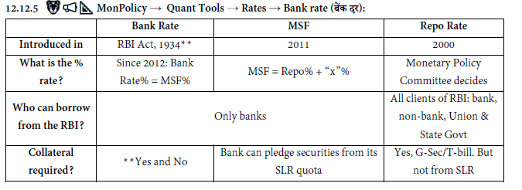

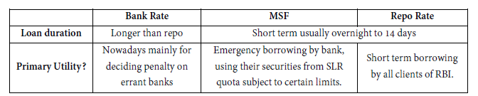

⇒ **RBI Act, 1934: “Bank rate is the standard rate at which RBI buys or **rediscounts** first class securities,

bills of exchange or other commercial papers.(-NCERT)” *rediscounting basically means the “repo-walla*

*game= RBI buys @x price, re-sells@y price where y>x”*

⇒ But, since the introduction of the Repo rate in the 2000s, the Bank rate has become a dormant tool (_नÜÝय

उपकरण) =not frequently used by RBI for lending or by banks for borrowing).

⇒ So, **reference books/websites differ** in its present operational status e.g. some of them would say:

o Bank rate requires no collateral and is meant for long term loans.

o Bank rate accepts collateral which can be both GSec/T-bill as well as private companies’

securities.

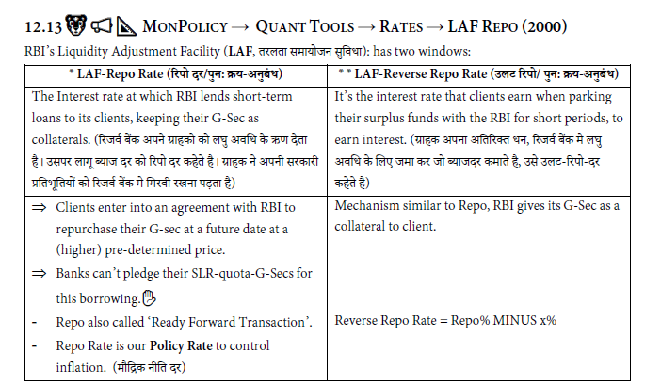

⇒ **Repo** = RBI lends short term loans its clients, & demands G-Sec/T-bill as collateral.

⇒ **Market Repo** = Players other than RBI (such as bank, NBFCs) loaning short money to other

Banks/NBFCs/Corporate Companies, and demanding financial securities (G-Sec/TBill/

shares/bonds/commercial paper etc.) as collateral. What do those terms mean? **Ans**. Ref the table

given in topic Operation Twist

**12.13.1 (2020)** 🐯🐯🐯🐯**:Repo Rate** ⏬ **to cheapen the loans & revive economy**

*Figure 4: कोरोना महामारी से जुज़ रही अथर्.व.ा पुनज._वत करने के .लए .रपो दर मे कटोती करना मंगता है।*

⇒ 2019: repo was in the range of 5-6%. Then, 2020-Corona → 👻👻Atmanirbhar Bharat RBI’s monetary

polices from Mar-April-May-2020 → REPO Rate ⏬ to 4%

⇒ **Stance:** Accommodative. Means in the next meeting they will either ⏬ repo or keep it unchanged. But

no chance of ⏫the repo rate in next meeting.

⇒ Theoretically: ⏬repo → ⏫demand → ⏫ inflation but, RBI expects that inflation will be under

control because:

⇒ Monsoon will be normal so food prices (& resultant inflation) will be under control.

⇒ Corona-led Economic slowdown → demand⏬ → inflation should⏬.

⇒ Crude oil prices also under control due to Corona slowdown.

⇒ Thus, inflation is going to be remain under control. Therefore, large reduction in repo rate WAS justified

to boost economic growth in 🤧🤧Corona.

😰😰**However, 2020-July-August:** CPI >6.5% which is above the 2-6% limit.

⇒ So, then, ideally RBI should ⏫the repo rate to combat inflation, but that will make the loans expensive

and harm the post-corona economic revival. so the RBI kept the repo rate unchanged. (महंगाई से लड़ने के .लए

अगर लोन महंग े कर िदए तो कोरोना महामारी पßात भारतीय अथर्तंत्र को पुनजà_वत करना मुáâल होगा → इस.लए _रजवर् ब§क के दरो ं म. कोई

बदलाव नही ं िकया गया)

⇒ Besides, the present inflation is caused by supply-side problems due to lockdown. Once the unlockdown

progresses → supply ⏫ → inflation ⏬. so changes in the repo rate not required at present. (लॉकडाउन

हटने पßात वैसे भी बाजार म. चीज व.ुओं क_ आपू_त बढ़ेगी तो अपने आप महंगाई काबू म. आ जाएगी, ऐसा _रज़वर् ब§क का सोचना था)

⇒ To conclude, Repo unchanged @4% from May-2020 upto 2021-November when I’m writing this note.

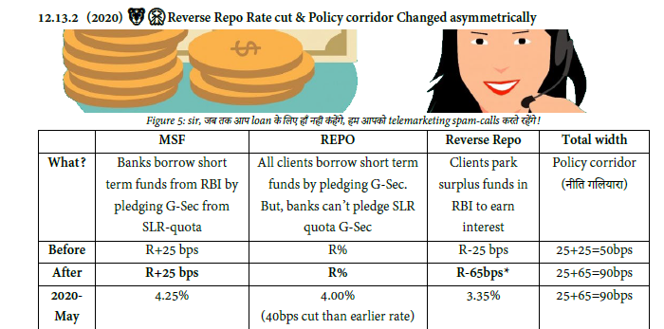

⇒ *Corona led economic slowdown → Loan demand ⏬ → banks parking their excess funds in RBI to

earn interest in the form of reverse repo rate. ब§क वाले अपना अ_त_रÂ धन _रज़वर् ब§क म. डाल के बैठे _बठाये ¨ाज कमा रहे थे.

⇒ **By 2020-March:** banks parked ₹~3 lakh crores in RBI in Reverse Repo.

⇒ So, RBI has drastically reduced ⏬the reverse repo rate to discourage such laziness of banks. (ब§को के इस

आलसीपन को दूर करने के .लए _रज़वर् ब§क ने _रवसर् रेपो रेट म. कटौती क_)

⇒ 😰😰Benefit of reverse repo reduction?

✓ IF SBI offers 5.9% Fixed deposit interest rate to depositors, and parks it in the RBI reverse repo

rate (3.35%) then SBI will actually make losses.

✓ So, RBI hopes SBI will now be ‘forced’ to give loans in a proactive manner (through SMS-spam,

email-spam and unwanted telemarketing calls etc)

Although as per 📔📔📔📔ES21, Banks still continued to park their surplus funds in Reverse repo because there

were not enough loan takers due to Corona slowdown.

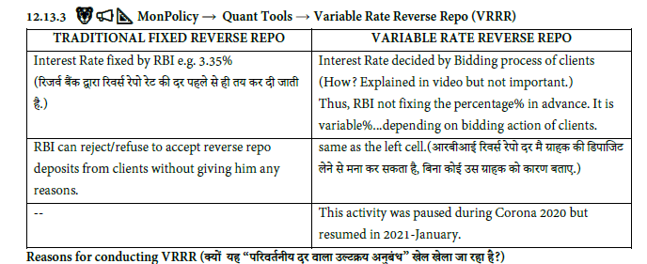

**Reasons for conducting VRRR**

⇒ Because RBI wants to suck excess money supply from the market without modifying the 'fixed' reverse repo %

⇒ Clients can hope to earn more interest rate in VRRR than fixed rate reverse repo. (VRRR नीलामी म . िकस प्रकार

क_ बो.लयां लगाई गई है उस िहसाब स े ग्राहक को शायद थोड़ा .ादा ¶ाज कमान े .मले)

**12.13.4 (2020)** 🐯🐯🐯🐯🐯🐯 **Long Term Repo Operations (LTROs: दीधर् अव_ध के रेपो ऋण)**

⇒ Usually, Repo loans are for short term borrowing from overnight to 14-days.

⇒ But, 2020-Feb: RBI announced to conduct Long Term Repo Operations (LTROs) of 1 yr & 3 years tenors.

⇒ RBI will loan total ₹ 1,00,000 crore, in various rounds through E-Kuber platform.

⇒ **Interest rate**: prevailing repo rate. Interest rate will be compounded annually. (वा_षक Æप से चक्रव.ृ द्ध ¶ाज)

⇒ This will ⏫ loanable funds with banks → economic growth can be revived. (आÉथक वृ.द्ध म. मदद होगी)

⇒ MSF and (short term) repo lending will also be continued separately as per their own existing norms.

LTRO doesn’t aim to eliminate / replace them

**12.13.5** 🐯🐯🐯🐯🐯🐯🐯🐯**:Targeted Long Term Repo Operations (TLTRO: ल.त दीघर्का¢लक रेपो)**

*Figure 6: @Banks- jo Long term REPO loan diyaa hai uskaa certain % you must give to Bond Market*

⇒ **Tenure?** upto 3 years

⇒ **Interest Rate?** FLOATING RATE linked with REPO Rate. Its exact formula? NOTIMP

⇒ **Total quantity?** First round 1.0= ₹1 lakh crore, round 2.0=₹50,000 crore and so on but figures NOTIMP.

⇒ If a bank borrows ₹₹ from this window → then

o within “X” number of days,

o bank must invest Y% of this borrowed money

o in Bond market/ debt securities (such as corporate bonds/non-convertible debentures,

commercial papers etc.) issued by “Z” borrower.

o “Z” could be a Corporates, Mutual Funds, Non-Banking Financial Companies (NBFCs) and

Housing Finance Companies (HFCs). (More in 📑📑Pillar#1B1: Classification)

⇒ 🤩🤩Benefit? (इससे £ा फायदा होगा)

o Debt securities are primary source of funding for NBFCs and HFCs. This measure will help them

obtain funds to revive business. (गैर ब§िकं ग _व¼ीय कं प_नयो ंको मदद .मलेगी)

o Similarly, Mutual Funds and industrialists who need funds, will benefit.

**12.13.6** 🎓🎓✋**TLTRO- Useless Doubts by novice students (बाबू-शोना /क£े ¤खला¥ड़यो ंके फालतू प्र¨)**

1. 🎓🎓✋Why would bank borrow ₹₹ in TLTRO if so many conditions are imposed on it? Ans. maybe the

bank feels it will earn profit from such investment. (उनको जÆरत होगी तो ल.गे, वरना नहीं ल.गे)

2. 🎓🎓✋Why would bank borrow ₹₹ in REPO rate (Short term) when TLTRO offering long term loans?

Ans. 1) depends on the requirement of the bank 2) TLTRO amount is finite e.g. first round total ₹1 lakh

given. So, if a banker came late to RBI’s shop, but Jalebi stock was finished , banker has to buy Samosa.

3. 🎓🎓✋ How does TLTRO involve “flight of foreign investors & its impact on exchange rate & bond yield”

etc.? **Ans**. Such long-winded-financial-cause-effect = no importance in UPSC, even though private mocktest-

walla design useless MCQs from it.

4. 🎓🎓✋I want to do PHD on this until Taimur grows up & gets married. **Ans**. Good luck to you! You keep

doing that, but, I’m finished teaching this topic here. #🕰🕰थोड़ा-पढ़ो-आग-े बढ़ो

**12.13.7** 🐯🐯🐯🐯🐯🐯🐯🐯 **RBI’s special or flexible liquidity window to help MF**

Franklin Templeton Mutual Fund (MF) decided to stop / windup some MF schemes in India, because they

couldnot generate good profit during the Corona crisis.

⇒ So, its Fund manager will liquidate (=sell off) the shares/bonds → return ₹₹ to investors.

⇒ Investors panicked because

o Fund manager did not give clear timelines about money refund.

o even if Fund manager tries to sell off shares/bonds, it is difficult to find buyers at the right price

so MF-investors may lose money.

o Alleged financial scam angle. (क_थत _व¼ीय घोटाला)

⇒ **RBI reform?** Special or flexible liquidity window to help Mutual Funds

o From this window, banks borrow from RBI → Bank uses it to either

▪ Give loans to Mutual Fund or

▪ Use the ₹₹ to buy debt-securities from Mutual Fund

😲😲✋ What is the total amount of funds in this special window? What is the tenure of loans

here? Do banks need to pledge G-Sec to borrow? How much interest is charged? Ans. Low profile

technical reform to a crisis affecting a small segment of financial market. #

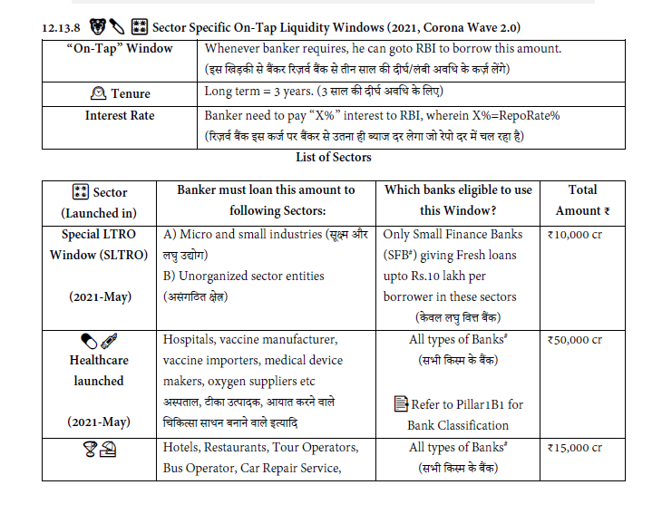

**12.13.9** 🐯🐯🐯🐯 🎛🎛 **Enhanced Reverse Repo Rate for Hardworking Bankers**

⇒ If Bankers uses Sector Specific On-tap Liquidity Window (e.g. bankers taking loans from RBI to lend to

hotel, beauty parlours, vaccine manufacturer etc). यिद कोई ब§कर _रज़वर् ब§क द्वारा बनाई गई .ेत्र _वशेष .खड़िकयों से पैसा कजर्

म. लेके _व_वध .ेत्रों को देता है

⇒ If this banker achieved Rs.“XX” loan giving target, then, IF he parks his surplus funds under Reverse

Repo Window → RBI will pay him 3.75% Reverse Repo Rate. (instead of 3.35% reverse repo paid to lazy

bankers.) तो उस मेहनतकश ब§कर को रीवसर् रीपो रेट म. _रज़वर् ब§क .ादा प्र_तशत ¶ाज देगी, अ¡ आलसी ब§करो ं क_ तुलना म..

⇒ 🤩🤩Benefit? It encourages bankers to work harder to give loans to various sectors.

⇒ 😤😤 **FAQ/Moral Outrage?** How / Why is this possible? How can banker borrow money and yet have

surplus funds? Ans. Banker will not instantly get all borrowers on day1. So, often he would invest his

surplus money (of depositors) temporarily in RBI (under Reverse Repo)- just to earn small amount of

profit, instead of letting the cash stay idle in his bank office. (ब§कर को यिद तुरंत कजर् लेन े वाला कोई ग्राहक नही ं .मले तो

छोटी अव_ध के .लए ब§कर अपना पैसा _रजवर् ब§क म. रखेगा ¶ाज कमाने के .लए)

**12.13.10** 🐯🐯🐯🐯🐯🐯 **MonPolicy → Quant Tools → Rates → MSF (2011)**

- **Marginal Standing Facility (MSF: सीमांत ªायी सु_वधा)** is the Interest rate at which RBI lends short-term

loans to Scheduled Commercial Banks (SCB) & Regional Rural Banks (RRB) with their SLR-quota G-Sec

as collaterals. (ऐसी खास .खड़क_ ह ै जहा ँ स े _रज़वर् ब§क द्वारा अनुसू·चत वा.णê.क ब§को तथा .ेत्रीय ग्रामीण ब§को ं को, उन ब§को के एसएलआर

कोटा क_ प्र_तभू_तयो ं को .गरवी लेकर _रजवर् ब§क उë . लघु अव_ध के कजर् देता है)

- MSF higher than Repo Rate. MSF = Repo% + 0.25%

**12.13.11 MonPolicy → Quant Tools → Rates- associated terms**

- ↔ **Policy Corridor:** It’s the width among MSF-Repo-Reverse Repo. Refer to reverse repo rate shortnote

for more. इन सब उपकरणो ंके बीच क_ चौड़ाई को “**मौ«द्रक नी_त ग¢लयारा”** कहा जाता ह ै

- **Window Operations:** LAF-MSF “windows” are operated through RBI’s E-Kuber Core Banking Solution

(CBS) platform.

- **(Uncollateralized) Standing Deposit Facility (SDF, ªायी जमा सु_वधा):** Banks parks funds in RBI for shortterm

to earn interest. No G-sec / collateral, unlike Reverse Repo. This helps RBI absorb excess liquidity

for short term in situations like demonetization when RBI may not have enough G-Secs to pledge as

collaterals. Urjit Patel Committee on Monetary policy (2013) proposed this, Budget-2018 agreed to

amend RBI Act for this. But not yet implemented. (_बना कुछ .गरवी रख,े _रवस र् _रपो का मज़ा .मलेगा)

- **Tri-Party Repo (.त्र-पीय पुन: क्रय-अनुबंध):** In ordinary repo, there are two parties- borrower vs. lender (RBI).

o In Tri-party Repo, there are 3 parties 1) borrowers 2) lenders 3) Tri-Party Agent (e.g. NSE or

BSE) who, acts as an intermediary between the two parties to facilitate collateral custody,

payment and guaranteed settlement.

o 2017: RBI issued guidelines → 2018: National Stock Exchange (NSE) started it, 2019: Bombay

Stock Exchange (BSE) started it.

o ⏬**This is not a tool of Monetary Policy**. It is meant to help Corporate companies to borrow

money from the market.(ये मौिद्रक नीती का िहÕा नही ं है)

- **BPLR, MCLR, External Benchmarks, Teaser Loans etc:** Terms related to how individual banks decide

their lending rates to borrowers. Ref: End section of this present handout.

- **Liquidity Trap:** To be covered separately in 📑📑Pillar-4Z: *Microeconomics*.

**12.13.12** 🐯🐯📢📢📁📁 **Market Operations (OMO, MSS): (Inflation → Sell G-Sec, Deflation → Buy)**

*Figure 7: Aloo Lelo, Pyaaz Lelo, G-Sec Lelo...*

I. **Open Market Operations** (खलु े बाजार क_ िक्रयाए): RBI buys and sells Union & State Govts’ securities to

control money supply.

o RBI buying= Money supply increased/liquidity injected in the market.

o RBI selling = Money supply decreased/liquidity absorbed from the market.

II. **Market Stabilization Scheme** (बाजार ±²रीकरण योजना): RBI sells special type of G-sec, T-Bill & Cash

Management Bills (CMB) to suck excess liquidity. ✋How it works? How is it similar or different

than OMO? Ans. NOTIMP. Very low profile thing for scope of UPSC. #🕰🕰थोड़ा-पढ़ो-आग-े बढ़ो

III. **Sterilization / Forex Swap**: Their primary objective is to control the currency exchange rate volatility

(e.g. $1=₹65,70,80…). *<More in* 📑📑*Pillar#3 >*

IV. **Operation Twist (2019):** a special type of OMO. Explained in next segment.

**12.14** 🐯🐯📢📢🗃🗃🧬🧬**MONPOLICY: QUANTI TOOLS: OMO → OPERATION TWIST**

Before that, you’ve to be aware of some many basic concepts:

**12.14.1** 🔪🔪🔪🔪**: Security → Debt → G-Sec & Bonds (ऋण के ¢लए जारी क_ गई प्र_तभ_ू तयां)**

A ‘Security’ means a certificate/document indicating that its holder is eligible to receive a certain amount of

money at a particular time. This could be a…

**12.14.2** 🛒🛒 **(**🔪🔪🔪🔪**:** 🧔🧔🧔**) Deepening of G-Sec market- Retail investors’ RDAG @RBI**

- RBI launched “Retail Direct Scheme” in 2021.

- Under this scheme, RBI permits “Retail Direct Gilt (RDG) account” for retail investors on its E-Kuber

online platform. (आम _नवेशक _रज़वर् ब§क म. आरडीजी नामक खाता खोल पाएंगे)

- Both Resident Indians & non-resident Indians (NRIs) can open this account. (गैर _नवासी भारतीय भी)

- Then Retail investors can directly buy Treasury Bills (T-Bill), G-Secs (of Union Government), State

Development Loans (SDL are ‘G-secs’ of State Govts) and Sovereign Gold Bonds, from RBI directly. (आम

_नवेशक सीधा _रज़व र् ब§क से इन प्र_तभू_तयो ं को खरीद सकता है.)

- Application fees to open the account = ₹ ZERO

− 🤩🤩**Benefit?** 1) Earlier retail investors bought G-sec “indirectly” through mutual funds wherein mutual

fund manager (MF) charged commission/fees. Now retail investor can buy directly so does not have to

pay such commission/fees to MF managers. (_बचौ.लयो ं को दलाली/कमीशन नही ं देना होगा)

− (More in 📑📑Pillar#1C- SEBI Share market, DEMAT account etc)

**12.14.3** 🔪🔪🔪🔪**:**🤵🤵**Corporate Bonds: factors that determine its interest rate**

If companies want to borrow money, they may issue bonds to investors. e.g. “*Whoever buys this Reliance Bond*

*worth ₹1000, we will pay him 9.40% interest rate per year and return the principal after 15 years*.” Usually the

interest rate offered on such bonds depends on

🔪🔪🔪🔪**:** 🤑🤑 **Bond Yield (बाडं म. _नवशे करने पर होने वाली आय या मनु ाफा)**

⇒ Bond yield is the profit an investor earns on a bond investment.

⇒ Suppose, Government issues a G-Sec or Bond: 8% annual interest, tenure: 1 year

⇒ Bhide Master invests ₹ 100. So, upon 1 year maturity he’ll get ₹ 8 Interest + ₹ 100 Principal = ₹ 108. So

his profit or yield will be= 8%

⇒ But suppose, before maturity of 1 year, Bhide Master urgently needs cash. So he sells ₹ 100 face-value

bond to Mr.Jethalal at a discounted price of ₹90. पैसों क_ अचानक जÆरत पड़ने पर स.े दाम म. िकसी को बेच दे

⇒ Jethalal keeps the it till maturity → Government pays him ₹ 108. प_रपí होन े तक बचे े नही ं